Annual Report
FY: -2080/81

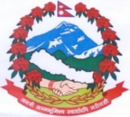

Government of Province
Gandaki Province
Ministry of Health
Health Directorate

Beni Hospital
Myagdi

TABLE OF CONTENTS :

A message from chairman of Beni Hospital Development Committee …………3
A message from Medical superintendent of Beni Hospital ……………………4
A message from Hospital Manager of Beni Hospital………………………….5
A message from Medical Recorder supervisor of Beni Hospital……………..6
Background and history of Beni Hospital………………………………........7-13
Human resources …………………………………………………………….14-18
Hospital Bed ………………………………………………………………...19
Hospital Related Instruments ………………………………………………………..20
Financial statements …………………………………………………………21-22
Hospital service statistics …………………………………………………..23-27
Minimum service standard follow ups ………………………………………28
Hospital activities, Achievements and challenges …………………………….29
Photo Gallery ………………………………………………………………..30-34

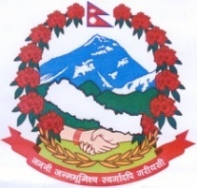
u08sL k|b]z ;/sf/
:jf:Yo dGqfno
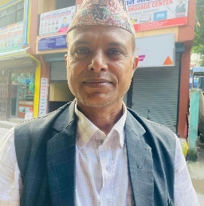
:jf:Yo lgb]{zgfno
a]gL c:ktfn
DofUbL .

z'esfdgf

g]kfnsf] ;+ljwfgn] :jf:Yo ;]jf hgtfsf] cfwf/e"t clwsf/sf] ?kdf cfTd;ft u/L gful/ssf] :jf:Yo k|lt /fHosf] bfloTjsf] P]ltxfl;s ?kdf :yflkt u/]sf] x'gfn] o; a]gL c:ktfnsf] c:ktfn ljsfz ;ldltsf] cWoIfsf] ?kdf z'esfdgf dGtJo cf=j= )*).*! sf] aflif{s k|ltj]bgdf /fVg kfpFbf cfkm"nfO{ v'zL dx;"; u/]sf] 5' .

o; k|ltj]bgdf ;dfj]z ul/Psf tYofFsx? a]gL c:ktfnsf] :jf:Yo Joj:yfkg ;"rgf k|0ffnL, s]lGb|o tYof+s ljefu tyf cGo pknAw ;|f]tx?af6 lnOPsf] xf . o; c:ktfnsf] tYof+sx? x]bf{ ut cf=j= eGbf k|ult pGd'v b]lvPsf] x'gfn] o; c:ktfnsf d]l8sn ;'kl/6]G8]G6 8f=cGh' yfkf Ho" nufot ;Dk"0f{ sd{rf/L tyf ;/f]sf/jfnf lgsfo k|lt cfef/ k|s6 ug{ rfxG5' .

cGTodf of] k|ltj]bg tof/ u/L k|sfzg ug{df vl6g'x'g] o; sfof{nosf c:ktfn Joj:yfkg clws[t >L k'hf aflgofF tyf ;Dk"0f{ kmfF6 k|d'vx?nfO{ wGojfb lbg rfxG5' . :jf:Yo;Fu ;/f]sf/ /fVg] ;+:yf, JolQm nufot cfd hg;d'bfosf nflu of] k|ltj]bg pkof]uL x'g] ck]Iff ub{5' .

;fy} cfufdL cf=j= )*१.*२ df klg o; c:ktfnsf] pQ/f]t/ k|ultsf] z'esfdgf JoQm ub{5' .

1fg]Gb| k|;fb ;'a]bL
cWoIf
c:ktfn Aoj:yfkg ;ldlt

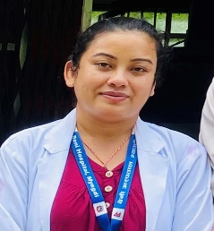
Gandaki Province Government
Ministry of Health
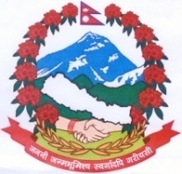
Health Directorate
Beni Hospital
Myagdi

Foreword

I am very pleased to have an opportunity to convey my message in this Annual Report of Beni Hospital, Myagdi for the fiscal year 2080/81. Timely Annual Report is a standard practice in health care service. Our annual report is an as-it-is snapshot of what we have achieved throughout the last fiscal year.

Beni hospital is evolving rapidly to a multi-specialty provincial hospital under the constant scrutiny of the Ministry of Health of Province-4. This hospital has been privileged to receive generous support from all the three levels of governments. Recently the attitude of the working staff of this hospital and the viewpoint of the general public toward this hospital is taking a positive trend. This Annual Report has organized in a book format; the joint effort of all the service providers of this hospital and the ripple effect it has created amongst the patients and the public.

I am confident that we will treasure this annual report and refer to it in multiple occasions during planning and decision making in the near future.

I would like to thank all the hospital staff for providing their whole-hearted effort in uplifting our hospital service quality towards excellence. Based on our performance in the revised MSS follow up, I am very hopeful that our hospital will become a role model amongst the provincial hospitals in the days to come.

Last but not the least, I would like to thank the report writing team for accomplishing this herculean task in time.

Dr. Anju Thapa
Acting Medical Superintendent
Beni, Hospital

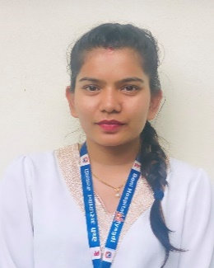
Gandaki Province Government
Ministry of Health
Health Directorate
Beni Hospital
Myagdi

Acknowledgement
It is my immense pleasure to offer the annual report of the Beni Hospital for the fiscal year 2080/81. This report is a compilation of the major activities carried out by Beni Hospital. The data presented in this report is based on the information submitted to the Heath Management Information System (HMIS) as well as other sources.
The report reflects information about health care services and activities of the Beni Hospital. The report also highlights the trend and pattern in service coverage and continuum of care. Furthermore, it also informs us about the program target and achievements. The report not only identifies pertinent issues, problems and complaints, but also suggests actions to be taken to address these issues in order to improve the services in the days to come.
I wish to express my sincere gratitude to the respected medical superintendent Dr.Anju Thapa for Her worthy direction. I am also thankful to the respected chairman of the hospital management committee for his encouragement.
I also extend my thanks to all the department heads and other staffs for providing their time and efforts on finding actual data and records.
I also extend my thanks to medical recorder supervisor Mr. Anil Sapkota and other officials for providing the actual data and records.
I also feel grateful to all the department heads and staffs of the hospital as well as who worked without rest for recording, reporting, compiling, processing and analyzing service delivery and progress report. Without your efforts publication of this report would not have been possible.
Finally, I hope that this report will be of enormous help in improving the health service provided by Beni hospital.
Ms. Puja Baniya
Hospital Management Officer

Gandaki Province Government

Ministry of Health
Health Directorate
Beni Hospital
Myagdi

Message
Dear Beni Hospital Team,
As we proudly present the Annual Report for Fiscal Year 2080-81, I would like to take this opportunity to express my heartfelt gratitude to each and every member of our esteemed team. This year has been a remarkable journey, filled with both challenges and significant achievements, and it is your unwavering commitment that has brought us to where we are today.
To our department heads and their dedicated teams, thank you for your leadership and tireless efforts. Your ability to adapt and innovate has been crucial in enhancing the quality of care we provide to our patients. Each department plays an integral role in the hospital's success, and your collaborative spirit has made a profound impact on our collective mission.
A special thanks to our Hospital Manager and Medical Superintendent. Your guidance and vision have been instrumental in steering us through complex situations, ensuring that we maintain our high standards of service and compassion. Your support fosters an environment where we can thrive and focus on what truly matters our patients.
This year, we have made significant strides in improving our processes, enhancing patient experiences, and promoting a culture of safety and excellence. I am particularly proud of how our team has come together, demonstrating resilience and a shared commitment to our goals. Your hard work does not go unnoticed, and I am grateful for the dedication you bring to your roles every day.
As we move forward, let us continue to support one another and strive for excellence in all that we do. Together, we have the power to overcome challenges and create a lasting impact on our community's health and well-being.
Thank you once again for your commitment and passion. Here’s to another year of growth, collaboration, and success at Beni Hospital.
Anil Sapkota
Medical Recorder Supervisor
Beni Hospital

Background:
This annual report includes introduction to all the services given by Beni hospital as well as comparative status of health indicators, financial and structural status, social, human resources as well as equipment available. It aims to report on the health service provider and the status of health service being given, especially focusing on women, poor and needy, and those living on rural areas. The main sources of data on this report are the publications relating to this district as well as data collected within this hospital premises.

With inclusion of health services as essential right for all Nepali citizen in the national constitution, this report has been published to inform citizens as well as and the those who need in accordance to ;+rfng tyf Aoj:yfkg P]g @)^#, ;+rfng tyf Aoj:yfkg lgodfjNfL @)^$, ;'rgfsf] xs ;DaGwL P]g @)^#, lghfdlt ;]jf P]g @)$(, lghfdlt ;]jf lgodfjNfL @)%), :jf:Yo P]g, @)%#, :jf:Yo lgodfjNfL and :YFFlgo lgsfo -cly{s k|zf;g lgofdfjnL, @)^$.

Introduction

Beni Hospital is located in ward no. 8, Beni of Myagdi district. It was first established as Beni health care center on the year 2042 B.S. as a 15-bed facility. Construction for a dedicated health facility began immediately and 15-bed was completed on the year 2045 BS. It was made into a 25-bed hospital on the year 2063 and named Myagdi district hospital. Finally, on the year 2072, it was upgraded to 50 bed hospital and named Beni hospital. As a primary as well as referral center for the district of Myagdi, the hospital has been providing quality services even with limited resources.
This hospital has an allocation for 59 permanent human resources including 10 specialist doctor, 4 medical officers and 1 dental surgeon to make a total of 15 doctors. However due to various reasons, this allocation has not been completed and the reduced government allocation has been boosted by MDGP and Internal Medicine Residents from TUTH and PAHS and a number of doctors from scholarship bonding by MOHP.
Cuerrntly, total 23 doctors including 8 Specialist Consultants, 2 Residents, 12 Medical Officers and 1 Dental Surgeon are providing various services like OPD( General Medicine, Geriatric, Pediatric, Obstetrics & Gynecology, Psychiatric, General Surgery, Orthopedics and Dental Surgery), Inpatients, Emergency and department wise Surgeries. The hospital has been running OPD services, Emergency services (24 hours), Indoor/ Inpatients ward services (24 hours), OT services including Caesarean Delivery, General Surgeries like Appendicectomy, Hydrocele, Hernia, Orthopedic and trauma surgeries etc.), Dental services, Screening services (USG and X-ray 24 hours) ,Lab Services (24 hours) Pharmacy services(24 hours ,Free maternity services (Safe Motherhood Program), SNCU,OCMC, Social Service Unit for targeted patients, Safe Abortion Clinic, ART counselling and medications (free of cost), TB and leprosy treatment, Hemodialysis and Physiotherapy services.
Beni hospital has started “Extended 7-8 OPD Program” from 2080/07/02 that run by Medical Officers. General OPD starts from morning 7 am and tickets are open till 8 pm at the same service rate which facilitates the opportunities for targeted people like Students, 10-5 Job Holders and Workers to visit in their off hours(7-10 and 5-8) and also insure quality care due to long service duration and availability of doctors.

Myagdi District

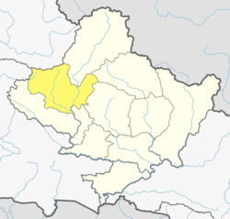

Administrative HQ: Beni
Total Area: 2,297 km² (887 sq. mi)
Total population: 113,641
Population density: 49/km² (130/sq. mi)
Telephone code: 069

Historical Background
Myagdi district is a hilly district which lies in Province No. 4 of the Federal Republic of Nepal. This district has its own historical identity. The district is named after the name of a river “Myagdi” which originates from mount Dhaulagiri and flows from North-West to the South-East of the district. There are different sayings behind origin of the word “Myagdi”. It is said that “Meng” means Thapa and “Di” means the river, combination forms the name of river “Mengdi”, the river that flows in the state ruled by Thapas. Later it turned into Myagdi however it is called Mengdi in Magar language still. There are many ancient and historically important places in Myagdi. The place where sage Jadbharat gave his lectures to the King of Rahugandh is located here as Jadbharat cave in Galeshwar. The place which is famous as the name “Raakhu” in the present days, is considered as the capital of Rahugandh of that time. Sage Pulatsya had been sheltered in “Pulaa” which is known as Pulachour VDC these days. Similarly, it is believed that the birthplace of grandson of Pulatsya the son of Bishwa the King of Lanka “Raawan” also lies here.
It is mentioned in history that the King of Lichchhavi Dynasty Mandev had suppressed the agitation of Mallapuri towards the opposite of Gandaki. The currency of Mandev I was found in Baglung so it is believed that the place Mallapuri was around Baglung and Myagdi. The first King of Thapa dynasty Kaalu Thapa (1246B.S.) had founded Takam State and the regime of Thapa dynasty continued for 300 years. In 1545 B.S. Dimba Bam Malla had defeated Thapas and merged all the today’s Dhaulagiri Zone’s districts to form a great Parbat state. Being a part of Parbat state formed by Bam Malla, Myagdi had its own identity. It is said that Kirti Bam Malla had established a palace in Dholthana and Thana in Beni. During the regime of Rana Bahadur Shah, Bahadur Shah had merged Parbat State into the Kingdom of Nepal and then Myagdi had been existed as an inseparable part. After the unification and during the Rana regime this district had been kept under the Palpa Administration. Later after the establishment of Baglung Gaundaa, all the administrative and judicial works carried out from there.

Political Division
During the general election of 2015 B.S. this place is included in Region No. 7. Later in 2018 B.S. as Nepal was divided into 14 Zones and 75 Districts, this place got its existence as Myagdi district lying in Dhaulagiri zone. At that time the district has 21 Village Panchayat. In 2032 B.S. 20 Village Panchayat from Parbat and Mustang were included so as to form 41 Village Panchayat and the district is divided into 9 Ilakas. After 2048 B.S. this district is divided into 41 VDCs, 11 Ilakas and 2 election constituencies. Later in 2051 B.S. only one election constituency is maintained on the basis of census of 2048 B.S. Along with the declaration of Beni Municipality formed by merging the 6 VDCs around the headquarter Beni in 2072 B.S, there are 35 VDCs and a Municipality in the district. This district has its boundary with Kaski & Parbat in the east, Baglung, Rukum & Dolpa in the west, Mustang & Dolpa in the north and Baglung in the south.

Geography and Climate
This district can experience 7 types of climates
Climate Zone^{[2]} | Elevation Range | % of Area
Upper Tropical | 300 to 1,000 meters  1,000 to 3,300 ft. | 0.1%
Subtropical | 1,000 to 2,000 meters  3,300 to 6,600 ft. | 17.5%
Temperate | 2,000 to 3,000 meters  6,400 to 9,800 ft. | 28.0%
Subalpine | 3,000 to 4,000 meters  9,800 to 13,100 ft. | 21.1%
Alpine | 4,000 to 5,000 meters  13,100 to 16,400 ft. | 17.8%
Nival | above 5,000 meters | 13.9%
Trans-Himalayan | 3,000 to 6,400 meters  9,800 to 21,000 ft. | 1.6%

Demographics
At the time of the 2011 Nepal census, Myagdi District had a population of 113,641. Of these, 94.2% spoke Nepali, 2.2% Magar, 1.0% Kham, 0.9% Chhantyal and 0.6% Newari as their first language.

Administration
The district consists of 6 Municipalities, out of which one is an urban municipality and five are rural municipalities. These are as follows:^{[4]}
- Beni Municipality
- Annapurna Rural Municipality
- Dhaulagiri Rural Municipality
- Mangala Rural Municipality
- Malika Rural Municipality
- Raghuganga Rural Municipality

Former Village Development Committees
Prior to the restructuring of the district, Myagdi District consisted of the following municipalities and Village development committees:
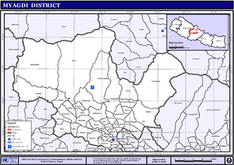
Map of the VDCs in Myagdi District
- Arman | - Bhanbare | - Marang
- Arthunge | - Bima | - Mudi
- Baadook | - Chimkhola | - Muna
- Babiyachaur | - Dagnam | - Nangi
- Baranja | - Kuhunkot | - Narchyang
- Begkhola | - Kuinemangale | - Niskot
- Beni Municipality | - Lulang | - Okharbot
- Bhakilmi | - Malkwang | - Pakhapani
- Patlekhet | - Rakhupiple | - Shikha
- Pulachaur | - Ramche | - Singa
- Rakhu Bhagawati | - Ratnechaur | - Takam
- Tatopani | - Ruma

Myagdi District, situated in the Dhaulagiri Zone of western Nepal, is celebrated for its stunning landscapes and vibrant cultural heritage. Nestled between the imposing Dhaulagiri and Annapurna mountain ranges, the district is a blend of rugged terrain, lush valleys, and serene rivers.

Geography and Climate
The geography of Myagdi is marked by significant elevation changes, from lowland areas to high mountain peaks. This topographical variation results in diverse climatic conditions, ranging from subtropical in the lower regions to alpine conditions at higher altitudes. These varying climates support a wide array of flora and fauna, enhancing the district’s appeal to nature lovers and trekkers.

Administrative and Cultural Aspects
Myagdi is administratively divided into several municipalities and rural municipalities, with Beni serving as the district headquarters. Beni is a crucial center for administrative, economic, and transport activities in the region.
The district is home to various ethnic groups, including Magar, Gurung, and Brahmin communities. These groups contribute to a rich cultural fabric characterized by vibrant festivals, traditional music, and dance. The Magar community, in particular, is known for its unique cultural practices and lively celebrations.

Economy
Agriculture is the cornerstone of Myagdi’s economy, with many residents engaged in farming and livestock rearing. The fertile lands support the cultivation of rice, maize, millet, and potatoes. Tourism also plays a significant role, driven by the region’s natural beauty and trekking opportunities.

Major Attractions
- North ABC (North Annapurna Base Camp): A distinguished trekking destination, North ABC offers trekkers spectacular views of the Annapurna range and a chance to experience the serene beauty of the Himalayas. It is a less frequented route compared to South Annapurna Base Camp, providing a more tranquil trekking experience.
- Poon Hill: This popular vantage point provides panoramic views of the Dhaulagiri and Annapurna mountain ranges. Poon Hill is especially renowned for its sunrise views, where the first light of day casts a golden glow over the majestic peaks.
- Rupse Waterfall: One of the highest waterfalls in Nepal, Rupse Waterfall cascades dramatically down a rugged cliff. Its breathtaking beauty and the surrounding landscape make it a must-visit natural attraction in Myagdi.
- Dhaulagiri: As one of the world's 14 peaks exceeding 8,000 meters, Dhaulagiri dominates the skyline of Myagdi. Its imposing presence and the surrounding area offer exceptional trekking and mountaineering opportunities.
- Gurja Himal: Part of the Dhaulagiri range, Gurja Himal is notable for its snow-capped peaks and remote beauty. It provides excellent trekking opportunities and stunning views, adding to the district’s allure for high-altitude adventurers.
- Narchyang Waterfall: Located near the village of Narchyang, this waterfall is renowned for its scenic beauty and serene surroundings. It is a favored spot for visitors exploring the natural wonders of Myagdi.
- Mohore Dada: An emerging attraction, Mohore Dada offers panoramic views of the surrounding landscape, including the Dhaulagiri and Annapurna ranges. Its elevated position provides a serene and picturesque setting, ideal for trekking and nature observation.

Challenges and Development
Myagdi faces typical challenges of mountainous regions, including infrastructure development and the impact of natural disasters like landslides. Nevertheless, ongoing efforts are focused on improving connectivity and enhancing services for residents.

मानव संसाधन (स्थायी तर्फ )
सि.न. | पदको नाम | तह | सेवा | समुह | स्वीकृत दरबन्दी |  | पदपुर्ति | रिक्त | कैफियत
१ | प्रमुख मेडिकल सुपरिटेण्डेन | ११औ | स्वास्थ्य | जनरल हेल्थ सर्भिसेज | 1 |  | 0 | 1
२ | प्रमुख कन्सल्टेण्ट अब्स्ट्रेसियन एण्ड गाईनोकोलोजि | ११औ | स्वास्थ्य | अब्स गाईनो | 0 |  | 0 | 0
३ | प्रमुख कन्सल्टेण्ट जनरल फिजिसियन | ११औ | स्वास्थ्य | मेडिसिन | 0 |  | 0 | 0
४ | प्रमुख कन्सल्टेण्ट पिडियाट्रिसियन | ११औ | स्वास्थ्य | पेडियाट्रिक्स | 0 |  | 0 | 0
५ | बरिष्ठ/कन्सल्टेण्ट अब्स्ट्रेसियन एण्ड गाईनोकोलोजि | ९/१०औ | स्वास्थ्य | अब्स गाईनो | 1 |  | 1 | 0
६ | बरिष्ठ/कन्सल्टेण्ट एनेस्थोसियोलोजिष्ट | ९/१०औ | स्वास्थ्य | एनेस्थोसियोलोजि | 1 |  | 0 | 1
७ | प्रमुख कन्सल्टेण्ट अर्थोपेडिक सर्जन | ९/१०औ | स्वास्थ्य | सर्जरी | 1 |  | 1 | 0
८ | प्रमुख कन्सल्टेण्ट साईक्याट्रिस्ट | ९/१०औ | स्वास्थ्य | साईक्याट्रि | 1 |  | 1 | 0
९ | बरिष्ठ/कन्सल्टेण्ट रेडियोलोजिष्ट | ९/१०औ | स्वास्थ्य | रेडियोलोजी | 1 |  | 0 | 1
१० | बरिष्ठ/कन्सल्टेण्ट सर्जन | ९/१०औ | स्वास्थ्य | सर्जरी | 1 |  | 0 | 1 | sfhdf bdf}nL c:ktfn
११ | बरिष्ठ/कन्सल्टेण्ट डेण्टल सर्जन | ९/१०औ | स्वास्थ्य | डेण्टिष्ट्रि | 0 |  | 0 | 0
१२ | बरिष्ठ/कन्सल्टेण्ट जनरल फिजिसियन | ९/१०औ | स्वास्थ्य | मेडिसिन | 1 |  | १ | ० | १ जना काजमा
१३ | बरिष्ठ/कन्सल्टेण्ट पिडियाट्रिसियन | ९/१०औ | स्वास्थ्य | पेडियाट्रिक्स | 1 |  | १ | ०
१४ | ब.अस्पताल नर्सिङ प्रशासक | ९/१०औं | स्वास्थ्य | जनरल नर्सिङ |  | 0 | 0 | 0
१५ | ब.कन्सल्टेण्ट ई.एन.टि. सर्जन | ९/१०औं | स्वास्थ्य | ई.एन.टि. सर्जन |  | 0 | 0 | 0
१५ | मेडिकल सुपरिटेण्डेन | ९/१०औं | स्वास्थ्य | जनरल हेल्थ सर्भिसेज |  | 1 | ० | १
१७ | मेडिकल अधिकृत | ८औ | स्वास्थ्य | जनरल हेल्थ सर्भिसेज |  | 4 | 2 | 2
१८ | डेण्टल सर्जन | ८औ | स्वास्थ्य | डेण्टिष्ट्रि |  | 1 | 2 | 1 | ! hgf kmflhn  @ hgf cWoog labfdf
१९ | शाखा अधिकृत | ७/८औ | प्रशासन | सामान्य प्रशासन |  | 0 | 0 | 0
२० | लेखा अधिकृत | ७/८औ | प्रशासन | लेखा |  | 0 | 0 | 0
२१ | फिजियोथेरापिष्ट | ७/८औ | स्वास्थ्य | फिजियोथेरापी |  | 1 | १ | ०
२२ | मेडिकल ल्याव टेक्नोलोजिष्ट | ७/८औ | स्वास्थ्य | मेडिकल ल्याव टेक्नोलोजी |  | 1 | 1 | ०
२३ | नर्सिङ अधिकृत | ७/८औ | स्वास्थ्य | जनरल नर्सिङ |  | 1 | 1 | 0
२४ | फार्मेसि अधिकृत | ७/८औ | स्वास्थ्य | फार्मेसि |  | 0 | 0 | 0
२५ | मेडिकल रेकर्डर सुपरभाईजर | ५/६/७औ | स्वास्थ्य | मेडिकल रेकर्डर |  | 1 | 1 | 1 | kj{t c:ktfn sfhdf
२६ | हेल्थ असिष्टेन्ट | ५/६/७औ | स्वास्थ्य | हेल्थ ईन्स्पेक्सन |  | 5 | 0 | 5
२७ | एनेस्थेटिक सहायक | ५/६/७औ | स्वास्थ्य | विविध |  | 0 | 0 | 0
२८ | फार्मेसि सहायक | ५/६/७औ | स्वास्थ्य | फार्मेसि |  | 1 | 1 | ०
२९ | बायोमेडिकल टेक्निसियन | ५/६/७औ | स्वास्थ्य | विविध |  | 0 | 0 | 0
३० | ल्याब टेक्निसियन | ५/६/७औ | स्वास्थ्य | मेडिकल ल्याव टेक्नोलोजी |  | 3 | 2 | 1
३१ | रेडियोग्राफर | ५/६/७औ | स्वास्थ्य | रेडियोग्राफी |  | 1 | ० | 0
३२ | स्टाफ नर्स | ५/६/७औ | स्वास्थ्य | जनरल नर्सिङ |  | 6 | 6 | ० | @ hgf cWoog labfdf
३३ | नायब सुब्बा | ५/६औ | प्रशासन | सामान्य प्रशासन |  | 1 | 1 | ०
३४ | लेखापाल | ५/६औ | प्रशासन | लेखा |  | 1 | 0 | 0
३५ | सहायक | ५औ | प्रशासन | सामान्य प्रशासन |  | 0 | 0 | 0
३६ | अ.हे.व. | ४/५/६औ | स्वास्थ्य | हेल्थ ईन्स्पेक्सन |  | 0 | 0 | ०
३७ | अ.न.मि. | ४/५/६औ | स्वास्थ्य | क.न.प.हे.न. |  | 6 | 1 | 5
३८ | डार्करुम असिष्टेण्ट | ४/५/६औ | स्वास्थ्य | रेडियोग्राफी |  | 1 | 0 | 1
३९ | डेण्टल हाईजिनिष्ट | ४/५/६औ | स्वास्थ्य | डेण्टिष्ट्रि |  | 1 | ० | १
४० | ल्याब असिस्टेण्ट | ४/५/६औ | स्वास्थ्य | मेडिकल ल्याव टेक्नोलोजी |  | 1 | १ | ०
४१ | खरिदार | ४/५औ | प्रशासन | सामान्य प्रशासन |  | 1 | ० | 1
४२ | कम्प्युटर अपरेटर | 4/5औ | विविध |  |  | 1 | 0 | 1
४३ | हलुका सवारी चालक | तह विहिन |  | मेकानिकल |  | 1 | 0 | 1
४४ | का.स. वा सो सरह | तह विहिन |  |  |  | 11 | @ | (
 | जम्मा |  |  |  |  | 59 | २६ | ३३

मानव संशाधन (करार तर्फ)

सि.न. | पदको नाम | तह | सेवा | समुह | स्वीकृत दरबन्दी | पदपुर्ति | रिक्त | कैफियत
१ | कन्सल्टेन्ट मेडिकल जनरलिष्ट (MDGP) | ९औ | स्वास्थ्य | जनरल हेल्थ सर्भिसेज | - | 0
२ | कन्सल्टेण्ट पिडियाट्रिसियन | ९औ | स्वास्थ्य | पेडियाट्रिक्स | - | 0
३ | कन्सल्टेण्ट जनरल फिजिसियन | ९औ | स्वास्थ्य | मेडिसिन | - | 1
४ | कन्सल्टेण्ट साईक्याट्रिस्ट | ९औ | स्वास्थ्य | साईक्याट्रि | - | 0
५ | कन्सल्टेण्ट रेडियोलोजिष्ट | ९औ | स्वास्थ्य | रेडियोलोजी | - | 0
६ | मेडिकल अधिकृत | ८औ | स्वास्थ्य | जनरल हेल्थ सर्भिसेज | - | 10
७ | डेण्टल सर्जन | ८ औ | स्वास्थ्य | डेण्टिष्ट्रि | - | 1
८ | नर्सिङ अधिकृत | ७ औ | स्वास्थ्य | नर्सिङ | - | 2
९ | मेडिकल ल्याव टेक्नोलोजिष्ट | ७ औ | स्वास्थ्य | मेडिकल ल्याव टेक्नोलोजी | - | 1
१० | ल्याब टेक्निसियन | ५ औ | स्वास्थ्य | मेडिकल ल्याव टेक्नोलोजी | - | 3
११ | हेल्थ असिष्टेन्ट | ५ औ | स्वास्थ्य | हेल्थ ईन्स्पेक्सन | - | 5
१२ | स्टाफ नर्स | ५ औ | स्वास्थ्य | जनरल नर्सिङ | - | 21
१३ | फार्मेसि सहायक | ५ औ | स्वास्थ्य | फार्मेसि | - | 4
१४ | डेण्टल हाईजिनिष्ट | ५ औ | स्वास्थ्य | डेण्टिष्ट्रि | - | 1
१५ | अप्थाल्मिक असिष्टेन्ट | ५ औ | स्वास्थ्य | अप्थाल्म | - | 1
१६ | अ.हे.व | ४ औ | स्वास्थ्य | हेल्थ ईन्स्पेक्सन | - | 6
१७ | अ.न.मि | ४ औ | स्वास्थ्य | क.न.प.हे.न. | - | 3
१८ | डार्करुम असिष्टेण्ट | ४ औ | स्वास्थ्य | रेडियोग्राफी | - | 0
१९ | स.लेखापाल | ४ औ | प्रशासन | लेखा | - | 0
२० | कार्यलय सहायक (खरिदार) | ४ औ | प्रशासन | प्रशासन | - | 0
२१ | हलुका सवारी चालक | बिहिन |  |  |  | 1
२२ | का.स. वा सो सरह | बिहिन |  |  |  | 30
 | जम्मा |  |  |  |  | 86

HOSPITAL BED:

Description | Total
Sanctioned Beds (Government) | 50
Sanctioned Beds (Development committee) | 0
Total operational Beds | 78
Total inpatient Beds( Surgical/ Pediatrics) | 18
Maternity Beds | 17
Medical ward | 18
ICU Beds | 5
Dialysis Beds | 6
No. of Ventilator & HFNC | 4
SNCU/NICU Beds | 3
Emergency Department | 6
Geriatric | 5
Others | -

Hospital Related Instruments.

Hospital Development Committee
Description
1. Financial Information | Amount (NPR)
2.1. Balance @end Asar 2080 | Rs.10513970.00
2.2. Income (service fees, rent, donation etc.) during 2080/81: | Rs.78011308.00
2.3. Expenses during 20780/81: | Rs.76040899.00
2.4. Balance @end Asar 2081 | Rs.368685.00
2.5. Details of any donation received, gift in kind | -
2. . Number of meetings held in FY 2080/81 | 8

Finance: Nepal government Budget
Budget | Budget Allocated | Budget Released | Budget Expenditure | प्रगति
 |  |  |  | भौतिक %
Capital | 80,00,000 |  | 77,05,620 | 96%
Recurrent | 10,14,24,000 |  | 6,97,21,981 | 68%
Total | 10,94,24,000 |  | 7,74,27,601 | 70%

अस्पतालको फार्मेसी
बिवरण | अवस्था
फार्मेसी संचालन गरेको मिति | वि.स. २०७२
फार्मेसीमा उपलब्ध औषधिहरूको संख्या | १३८५
फार्मेसीमा कार्यरत जनशक्ती संख्या (जना) | ७
Software को अबस्था (उपलब्धता, अवस्था) | उपलब्ध 5 .
आम्दानी रकम (रू) | ६०७५०२५.००
o; cf=a=को खर्च (औषधि खरिद, कर्मचारी तथा अन्य) रू. | १,००,००,०००

Hospital Services

Indicators | 2078/79 | 2079/80 | 2080/81
Doctor patient ratio in OPD | 1:13680 | 1:11140 | 1:2957
Outpatient Sex Ratio | 76 | 75 | 73
Inpatient Sex Ratio | 57 | 63 | 90
Deaths within 48 hours of Admission | 2 | 0 | 1
Deaths after 48 hours of Admission | 1 | 0 | 6
Average number of X-ray per day | 23 | 26 | 43
Average number of USG per day | 24 | 26 | 26
Average number of ECG per day | 7 | 6 | 11
Average number of Laboratory tests per day | 63 | 66 | 74

Hospital patient Data

Services | 2078/79 | 2079/80 | 2080/81 | Trend
Emergency | 8810 | 8145 | 7572 | Decreasing
OPD | 40110 | 50281 | 73930 | Increasing
Admissions | 2639 | 2767 | 2265 | Increasing

Extended OPD Services ( 7 AM - 8 PM ) Started from Kartik 28
TIME | 7 AM-10AM | 10AM-2PM | 2PM-8PM | TOTAL
MANGSIR 2080 | 1172 | 1823 | 642 | 3637
POUSH 2080 | 1267 | 2060 | 623 | 3950
MAGH 2080 | 1211 | 2033 | 579 | 3823
FALGUN 2080 | 1377 | 2078 | 665 | 4120
CHAITRA 2080 | 1496 | 1967 | 719 | 4182
BAISHAK 2081 | 1609 | 1627 | 797 | 4033
JESTHA 2081 | 1802 | 2105 | 885 | 4792
ASHAD 2081 | 1451 | 1720 | 754 | 3925

Lab Services (Patient no.)
 | 2077/78 | 2078/79 | 2080/81
Total tests | *** | *** | 27160

Imaging Services
 | 2078/79 | 2079/80 | 2080/81
X-ray | 8817 | 9498 | 15895
USG | 8467 | 9341 | 9636
ECG | 2813 | 2224 | 4013

Birth Type
 | 2078/79 | 2079/80 | 2080/81
Spontaneous | 799 | 676 | 273
CS(Cesarean section) | 172 | 114 | 97
Total | 971 | 790 | 370

Safe Abortion indicator
Indicator | 2078/79 | 2079/80 | 2080/81
1. No of CAC (Surgical Abortion) | 23 | 5 | 1
2. No of CAC (Medical Abortion) | 331 | 246 | 318
3. Proportion of <20 yrs women receiving abortion service | 16 | 9 | 14
4. No of abortion complication | 0 | 0 | 0
5. Proportion of Long-term contraception among post abortion contraception used | 158 | 24 | 71
6. No. of Post abortion Care | 63 | 43 | 93

Surgeries Performed.
 | 2078/79 | 2079/80 | 2080/81
Minor surgeries | 1214 | 1261 | 1647
Intermediate surgeries | - | - | 569
Major surgeries | 76 | 43 | 98
Total surgery | 1290 | 1304 | 2314

 | 2078/79 | 2079/80 | 2080/81
Post mortem done | 76 | 70 | 50
Post-mortem done:

Hospital Deaths FY 2080/81

- Number of Maternal Death at Hospital : 0
- Number of Neonatal Death at Hospital :0
- Number of Perinatal Deaths in hospital :1
- Number of still births :0
- Number of early neonatal deaths :0
- Number of hospital maternal deaths reviewed : 0
- Number of hospital perinatal deaths reviewed : 12
Causes of Death /Response/Way Forward: UTI with absent fetal movement /spontaneous progress of labor/ Counseling and anticipation.

Status of the major indicators

Indicators | 2078/79 | 2079/80 | 2080/81
Percentage of monthly report entered | 100 | 100 | 100
Percentage of monthly report entered within Time | 100 | 100 | 100
Bed occupancy rate | 32 | 29.4 | 27.95
Average length of stay | 2.4 | 2.2 | 3.11
Throughput | 4.1 | 4.7 | 4.9
Bed turnover interval | 88.6 | 87.4 | 82.35
Percentage of surgeries among inpatients | 12.08 | 17.4 | 6.04
Infection rate among surgical cases | 0 | 0 | 0.7
Surgery related death rate | 0 | 0 | 0

Early Warning & Reporting System (EWARS)

Immediate Report (in number) | 2023 | 2024
Weekly reporting (number of weeks) | 52 | 36
Reported Diseases | Number
AGE | 21 | 188
Cholera | 0 | 0
SARI | 0 | 4
Malaria | 0 | 0
Kalazar | 0 | 0
Dengue | 107 | 81
Scurb typhus | 72 | 82
Others

Hospital Based One Stop Crisis Management Center (OCMC)

Type of Crime | Total number of cases (New)
Type of Crime | 2078/79 | 2079/80 | 2080/81
Sexual Assault | 15 | 14 | 19
Physical Assault | 14 | 26 | 29
Domestic Violence | - | - | 8
Other | 2 | 2 | 1
Total | 31 | 42 | 57

Total Patients Served by Social Service Unit FY 2080/81

Target Group | Number
Target Group | 2079/80 2080/81
Ultra Poor and Poor | 80 217
Helpless | 22 1
Person with Disability | 67 44
Senior Citizen | 51 914
Victims of Gender Based Violence | - -
Others | 8 10
Total | 476 1186

Minimum Service Standard

Major Achievements during FY 2080/81

- Extended OPD Service ( 7 am to 8 pm ) including Saturday and Public Holidays
- General Anesthesia Station Installation and Surgeries under GA
- Laparoscopic Tower Installation
- HMC’s OMN Survey and recruitment of required human resources
- Specialist Services Expansion : General Surgery, Orthopedics with continuation of Geriatric, Psychiatric and Gynecology & Obstetrics
- Addition of 2 Hemodialysis Machine with total 7 functioning bed serving 30 patients.
- Various Orientation Program including EWARS and OCMC
- Screening Program for Cervical Cancer ( VIA) in various rural areas of Myagdi District

Hospital Entrance & OPD BLOCK

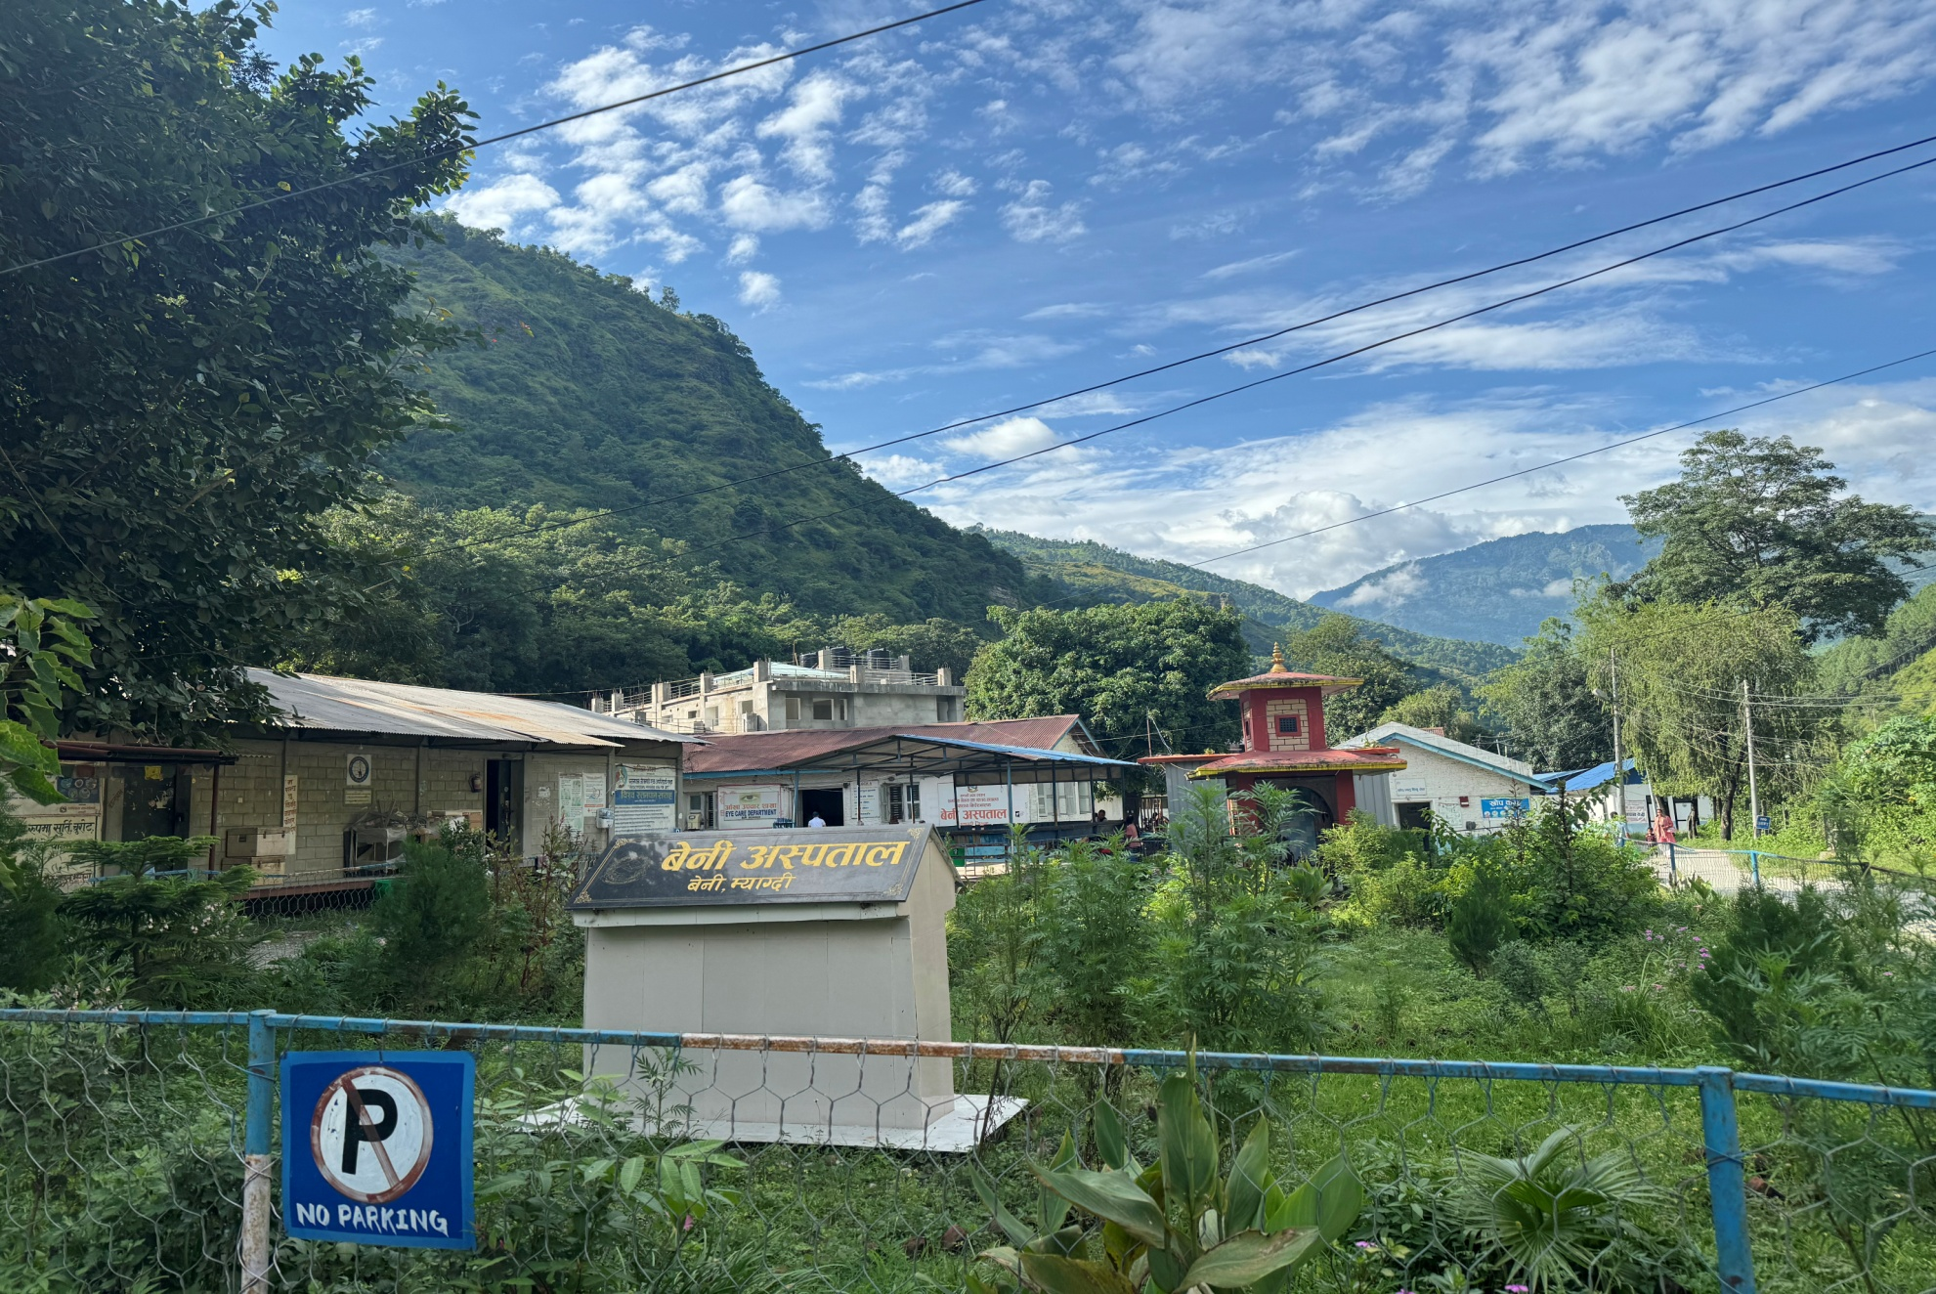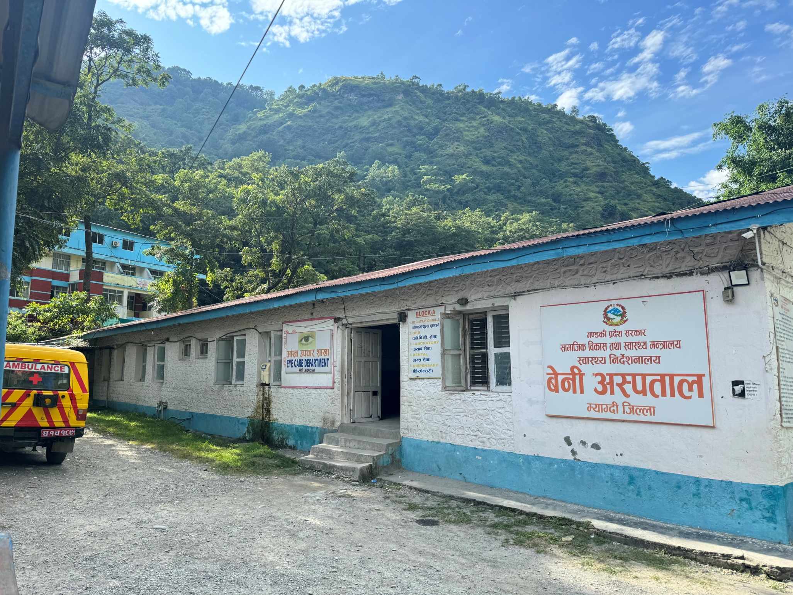
Hospital Parking areas, Inpatients Blocks ( Medical and Maternity wards)

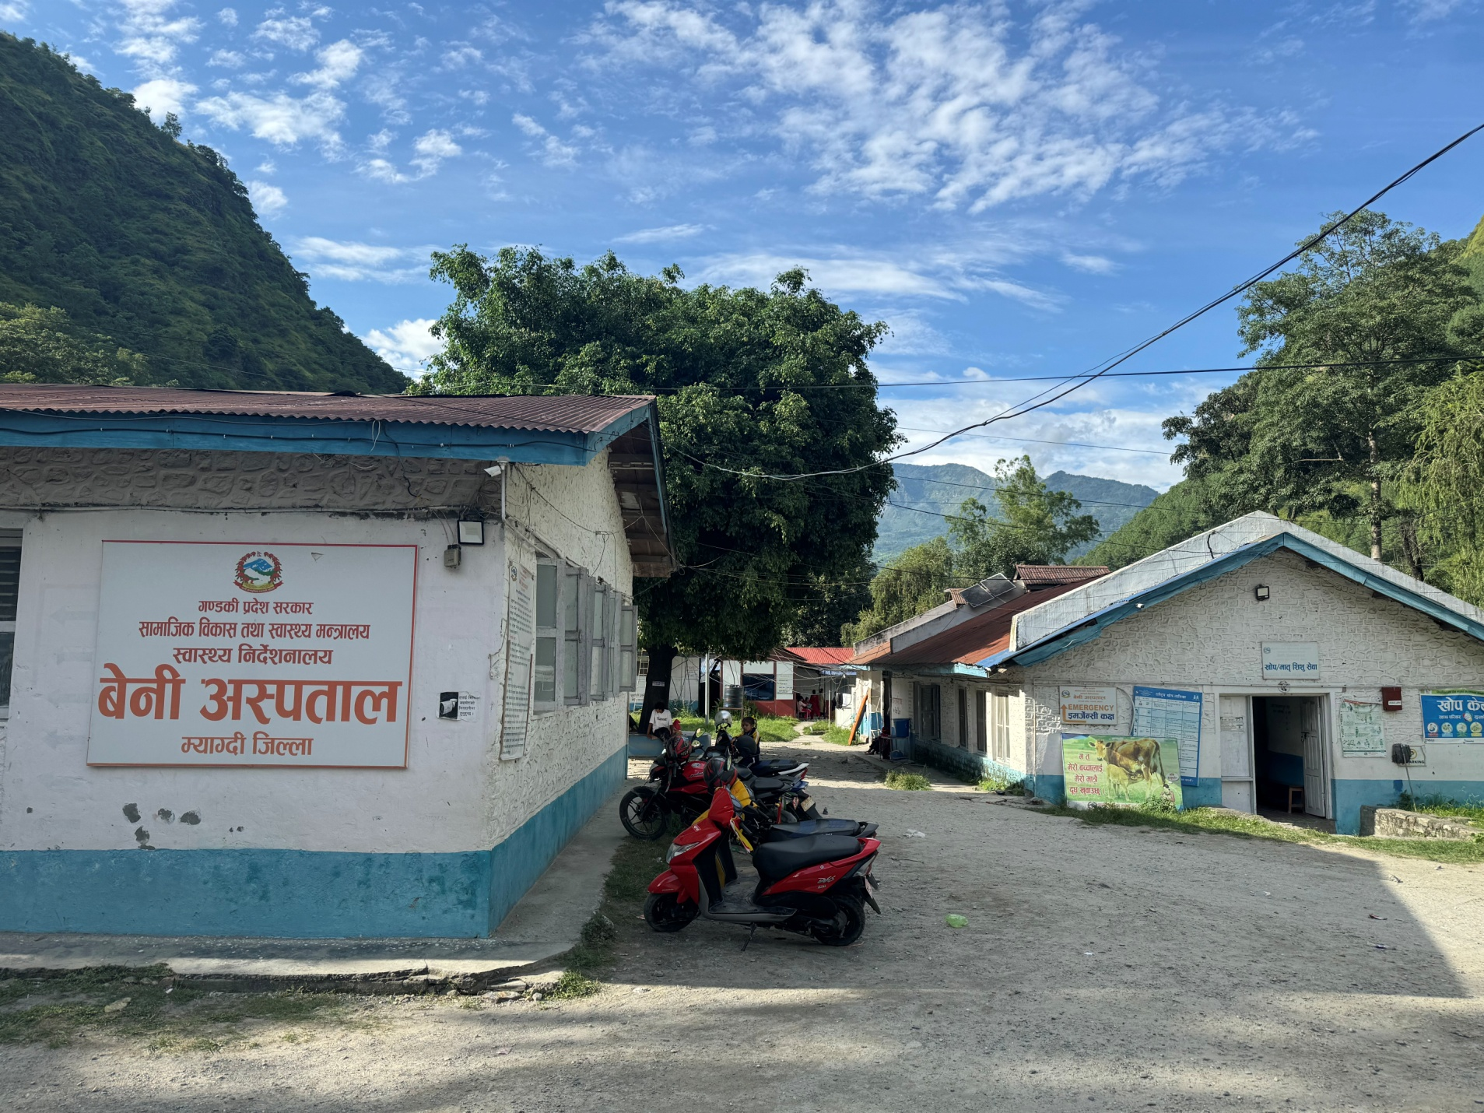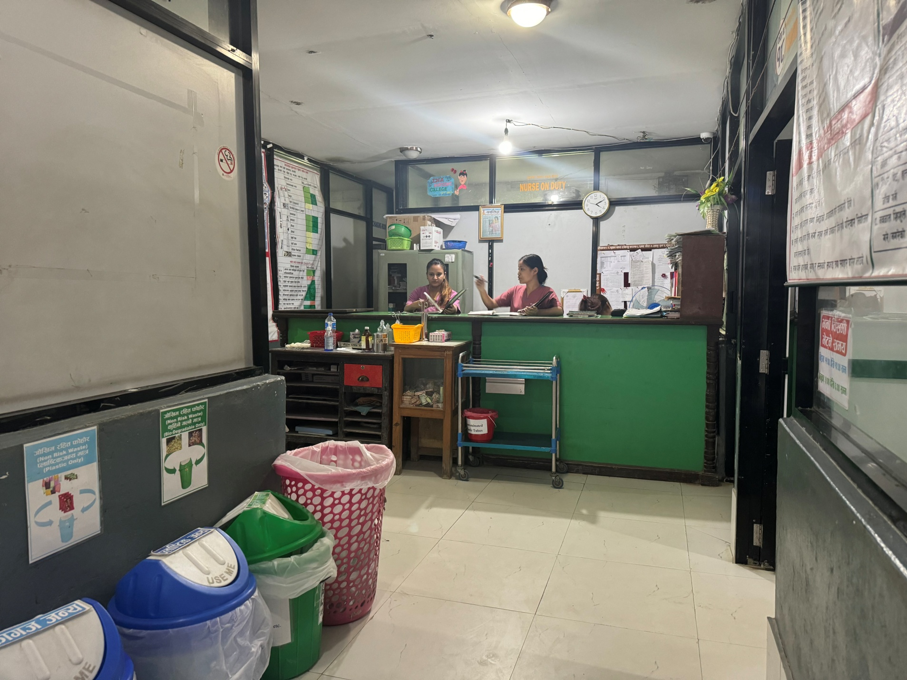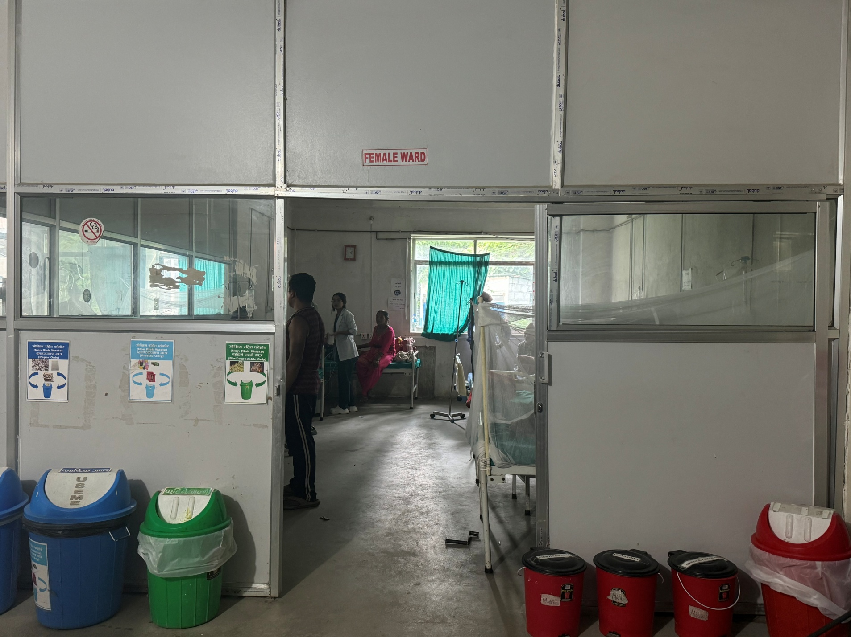

PICU & Emergency block

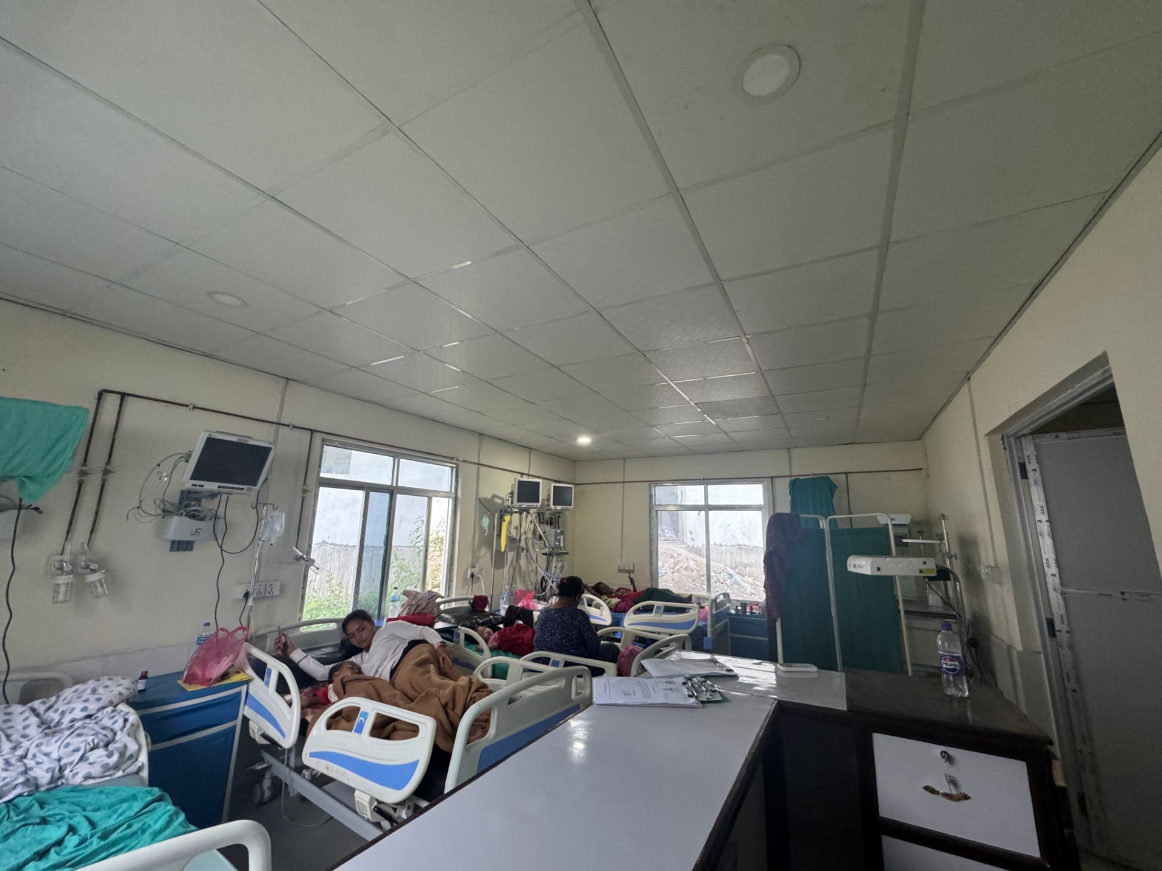
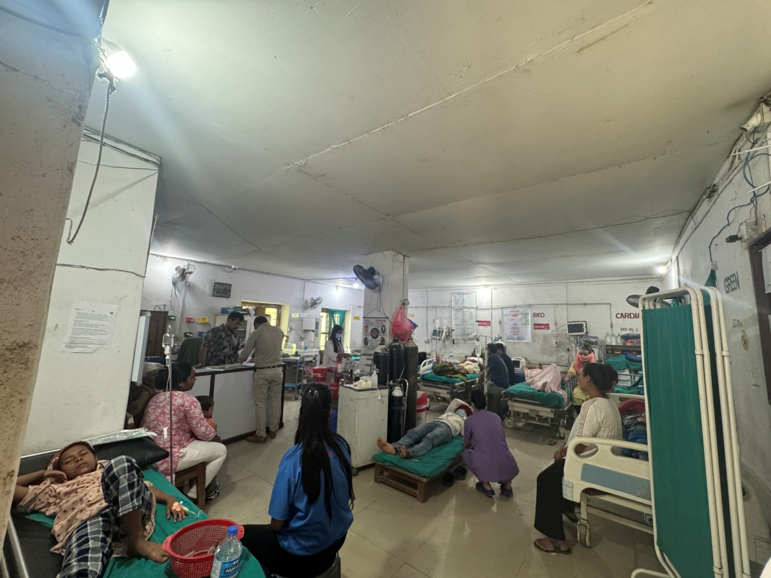
Under constructed building of beni Hospital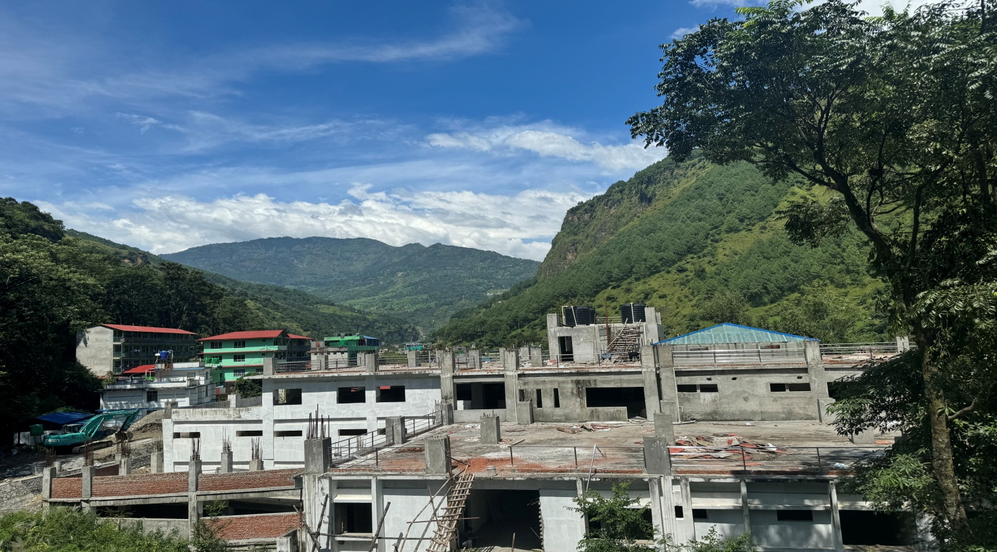

MASTER PLAN OF BENI HOSPITAL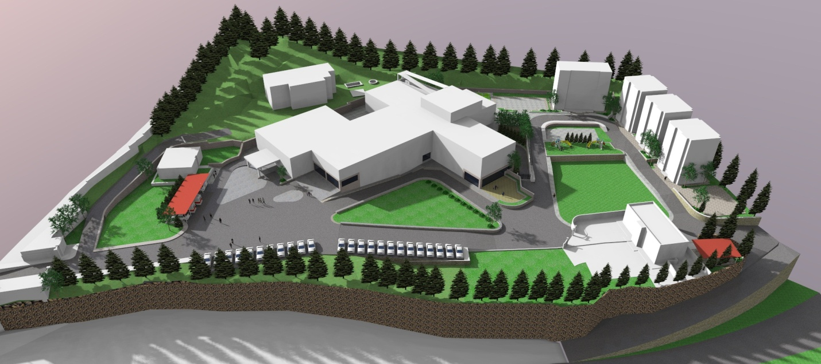

MASTER PLAN FOR 50 BEDDED HOSPITAL
